**Overview of Views:**

In SAP ABAP a View acts like a database table, But it will not occupy storage space. A view acts similar to a virtual table - a table that does not have any physical existence. A view is created by combining the data of one or more tables containing information about an application object.

There are 4 types of views:

1)Database View

2)Projection View

3)Help View

4)Maintenance View

**1)Database View**

A View created on two or more tables by clubbing the fields using inner join is called Database View.

* Maintenance operation not possible
* As inner join is used only matching record will be fetched

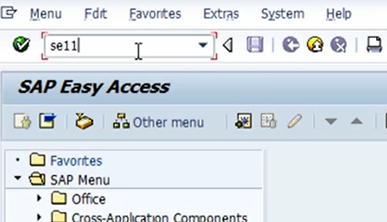

SE11 T-code

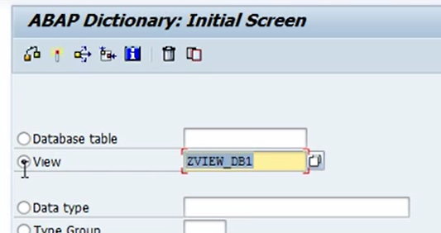

Select View and enter the name start with Z

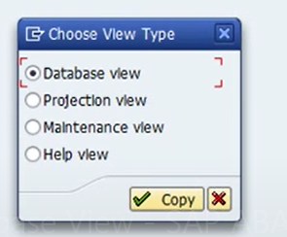

Select the appropriate view.

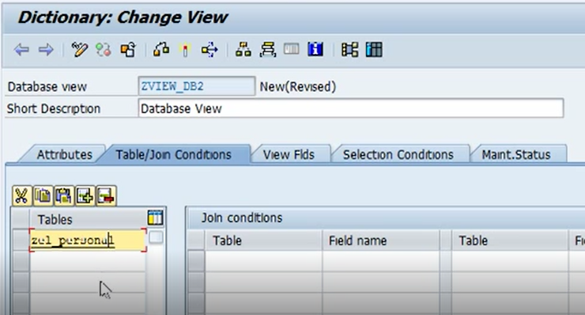

Enter short description and table details.

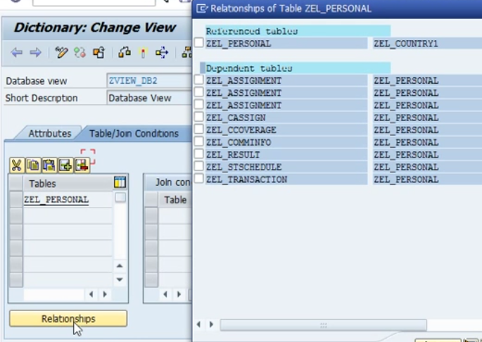

Click on table name and then Click on Relationship Button.

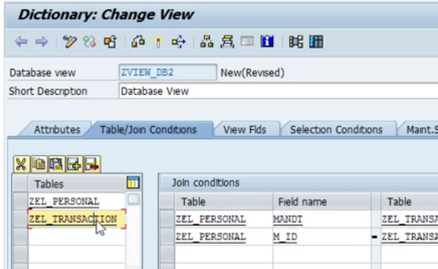

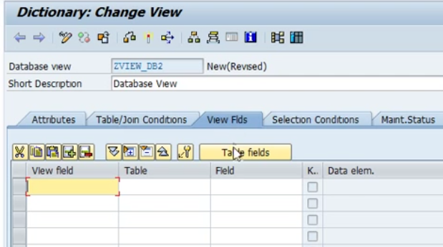

Click on View Field tab

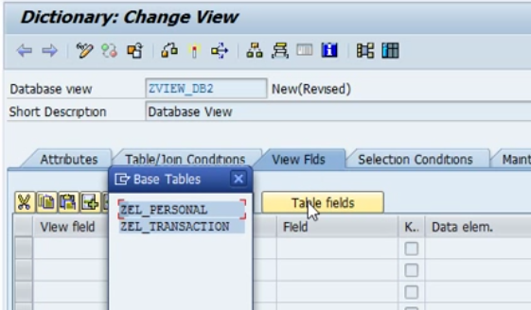

Click on Table fields tab.

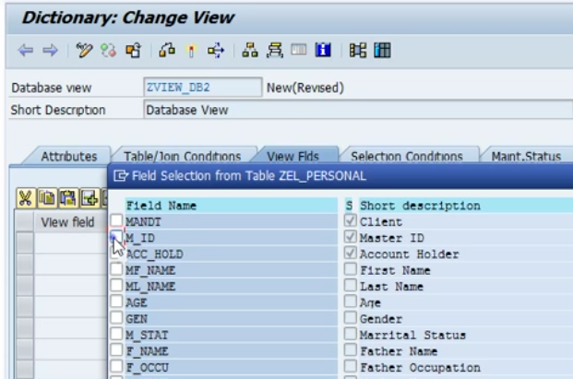

Select the fields.

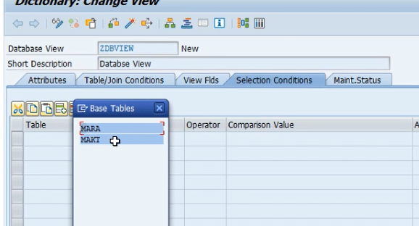

In section Condition tab you can input the selection conditions.

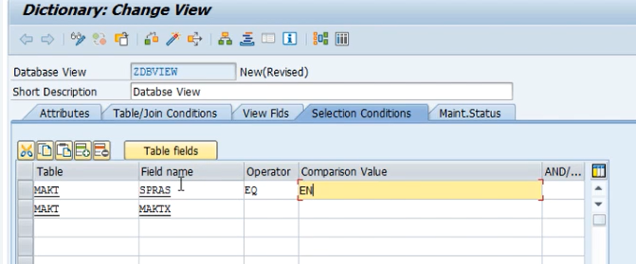

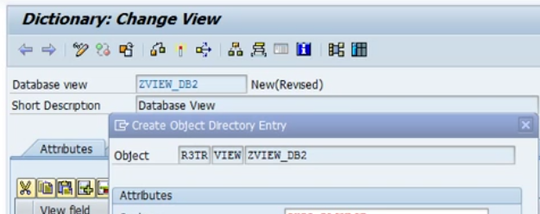

Save and activate.

Database View Created.

**2)Projection View**

* Created on single table only.
* Maintenance operation is possible

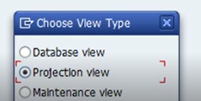

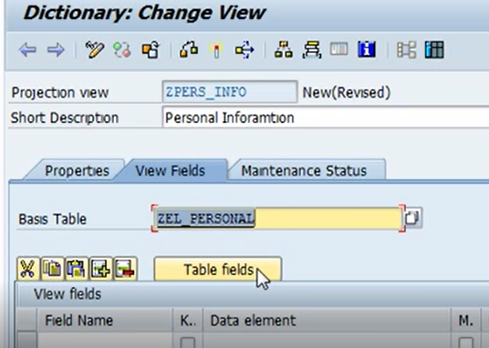

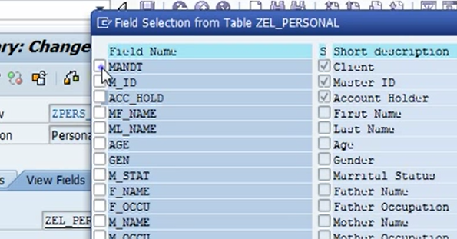

Save and activate if required can add maintenance operation in Maintenance Status Tab.

**3)Help View**

* Created on two or more tables for “Search-Helps”
* Uses Outer join concept
* Cannot maintain the data

**4)Maintenance View**

* View created on two or more tables using inner join.
* Can Read and maintain data
* Maintenance view should not be created on Standard table.

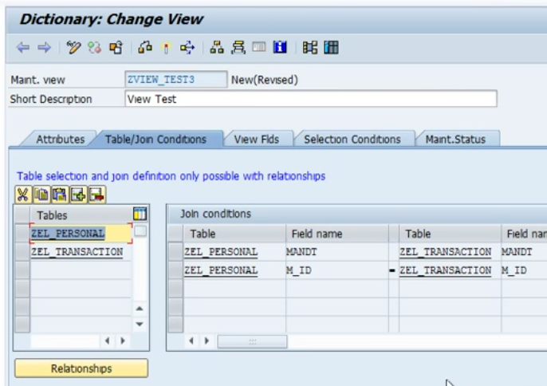

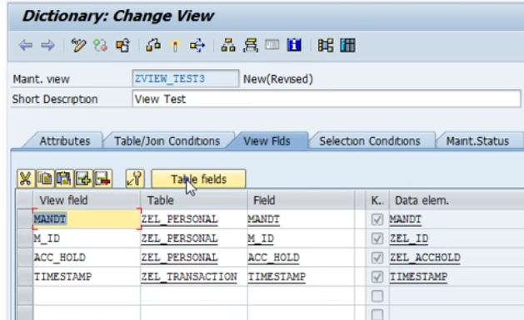

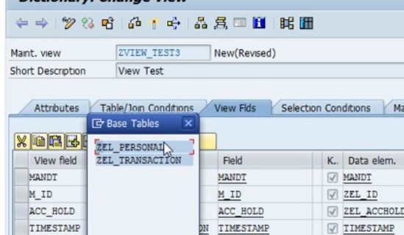

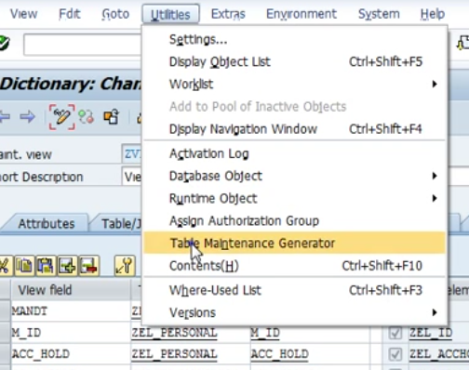

Create TMG through Utilities.

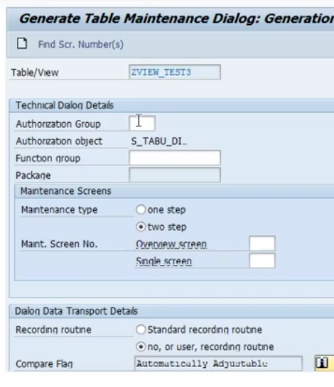

Save and activate.